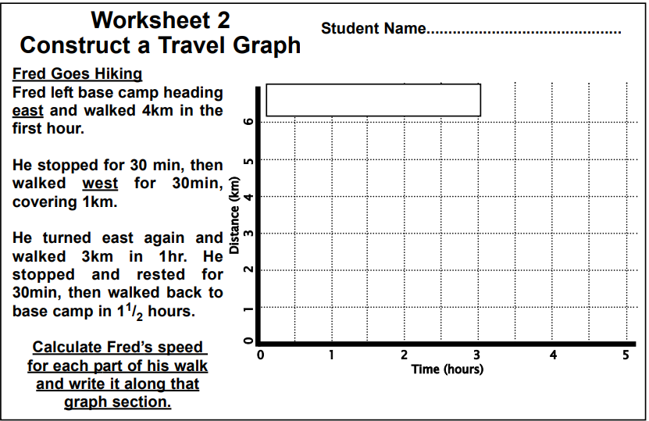

**EXIT TICKET**



**EXIT TICKET**



**EXIT TICKET**